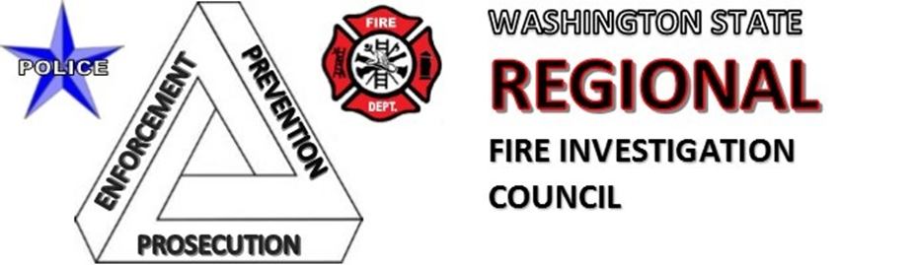

General Meeting Minutes for December 2, 2025

Present:
Andrew Bergford | Jameal Hampton | Mike Homan
Chris Bamer | Jason Kestle | Randy Haines
Chris Pedersen | Jason Rickey | Robin Irvine
Cole Roberts | Jimmy Grostick | Ross Fryberg
Douglas Werts | Jon McKinnon | Ryan Montero
Emily Wolfe | Josh Rogers | Scott Austin
Eric Dyer | Ken Goll | Spencer Baumgartner
George Stoess | Kurt Blanchard | Steve Goforth
 |  | Steven Crown

- Please let Chris Bamer know if you would like to be added to the distribution list

Opening: Washington State Regional meeting called to order at 10:02 am

Approval of Minutes:

- Meeting minutes from October were approved.

Treasurer’s Report:

Savings: $ 11,110.74
Checking: $ 9,446.55
Total: $20,557.29

Committee Reports

Training Committee

- KCSO-FIU recently hosted a training. There were approximately 60 attendees (from 13 different counties or about 1/3 of the state). The morning session covered legal concepts relevant to fire investigations and the presenters were the King County Prosecuting Attorney’s Office, King County Sherrif’s Office Advance Training Unit, and the King County FIU. The afternoon session covered report writing and the presenters were Norm Golden and Alan Predmore. Contact Steven Crown if you would like the PPTs. And contact Tom Devine with ideas for future training (Thomas.devine@kingcounty.gov).
- CFITrainer.Net has two new modules.
- The National Fire Academy is accepting applications again.
- Legal & Liability and Risk Management is offering a course on conducting comprehensive fire investigations while complying with NFPA 1321. The two-hour course is on 12/15/25, costs $150, and can be viewed by a team. The course is tested.
- The 2026 Fire Investigation Conference is scheduled for May 4th through May 8th. The classes and registration information is to be determined. Visit the WA State IAAI website for further information.

Website Committee

- Pending applications were approved.
- A couple of people were emailed to confirm membership.
- Officers can update their profile with a photo.
- New article may be getting posted to the website.
- Organization files will be moved to the WSRFIC website so they are accessible to the board.
- Contact Steven Crown with any ideas for improving the website.

Old Business

In-Person vs. Virtual Meetings

- We tried out a hybrid model for our December meeting. Thank you to Ken Goll and Puget Sound Regional Fire Authority for hosting!
- The February meeting will also be hybrid, and the space can accommodate 26 people. So, come join us in person if you can! (See details at the end of this document.)

Executive Board

- There was a last call for Executive Board nominations.
- Jason Berman will continue his role on the Board as a Director.
- David Bustamante from Navy Region Northwest and Dan Lorentzen from Snohomish County also joined the Board as Directors.
- Position #5 has been open for years, and there is no restriction on what county the member is from.
- The bylaws dictate that the Board will meet at the end of the year and determine who the next Chair will be.

New Business

WSP North Bend Fire Training Academy

- WSRFIC signed an updated facility use agreement. This new agreement expires at the end of November 2030.
- The largest obstacle in reducing costs continues to be the cost of insurance. VFIS is our current insurer and that contract renews in April. Please contact us if you have any experience in general liability insurance or ideas on how to reduce this cost.
- There was discussion about having the FTA take over the process and physical props so that WSRFIC is not responsible for usage and insurance costs. The Executive Board plans to consider this option as it charts a path forward for the organization.

Certification Updates

- Alan Predmore shared that the certification process for State Fire Marshal’s Office IFSAC/Pro Board certification for Fire Investigator is undergoing some changes.
- This includes an update to the skill sheets and written test. The questions for the written test will now come from the Jones & Barlett Fire Investigator book. This change will align with recent changes with IAAI. Students who take their fundamentals course directly from IAAI or an approved alternative will be able to apply this course towards the IAAI FIT or CFI credentials.
- Under review are two options for obtaining a certification. Track #1 is what is currently in place: candidates take a written test and then a practical test. Track #2: candidates take a written test, are evaluated at an actual fire scene by an evaluator, and then submit a portfolio of their work (reports, diagrams)
- The next steps are for the TAG to review the proposed changes. If approved, the State Fire Marshal’s Office will then have to work with IFSAC and Pro Board.

Good of the Order and Closing

- Closing: Washington State Regional meeting was called to close at 10:30 am

The next meeting will be held on Tuesday February 3rd at 10:00am. It will be a hybrid meeting with an option to meet in-person at Puget Sound Regional Fire Authority (20811 84th Ave S, Kent, WA 98032). Parking will be on the north and east sides of the building with the entrance being mid-span on the east side as indicated with a red arrow below. Thank you to Ken Goll and Puget Sound Regional Fire Authority for hosting!!

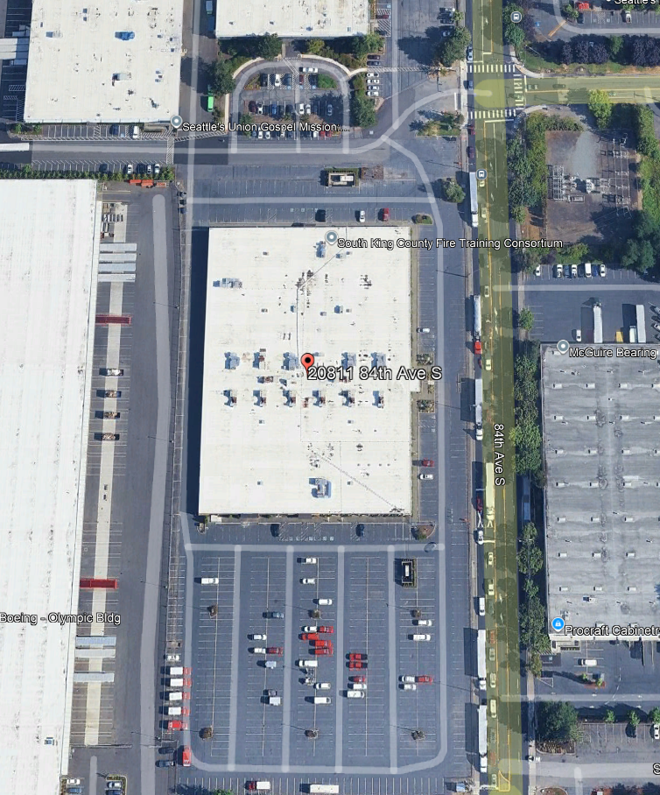

For those unable to attend the in-person, here is the information for Teams:

Microsoft Teams Need help?
Join the meeting now
Meeting ID: 245 003 259 26
Passcode: GP3Dr6kB

Dial in by phone
+1 206-686-8357,,419198544# United States, Seattle
Find a local number
Phone conference ID: 419 198 544#
Join on a video conferencing device
Tenant key: seattle@m.webex.com
Video ID: 112 426 197 1
More info
For organizers: Meeting options | Reset dial-in PIN

